Breast Cancer Prediction using Machine Learning
Name: Tapasya Kumar
Internship: AI Internship
Project: ML Classification Project
Organization: Alfido Tech

1. Introduction
This project focuses on predicting breast cancer diagnosis using machine learning techniques. The system classifies tumors as malignant or benign using medical diagnostic features.
2. Objective
The objective of this project is to build a machine learning model capable of accurately predicting breast cancer diagnosis using classification algorithms.
3. Dataset Description
The Breast Cancer Wisconsin Dataset was used in this project. The dataset contains diagnostic measurements computed from breast mass images.
dataset: https://www.kaggle.com/datasets/uciml/breast-cancer-wisconsin-data
4. Technologies Used
- Python
- NumPy
- Pandas
- Matplotlib
- Seaborn
- Scikit-learn
- Jupyter Notebook

5. Data Preprocessing
The dataset was cleaned by removing unnecessary columns and converting categorical labels into numerical values. Feature scaling was also performed using StandardScaler.

6. Exploratory Data Analysis
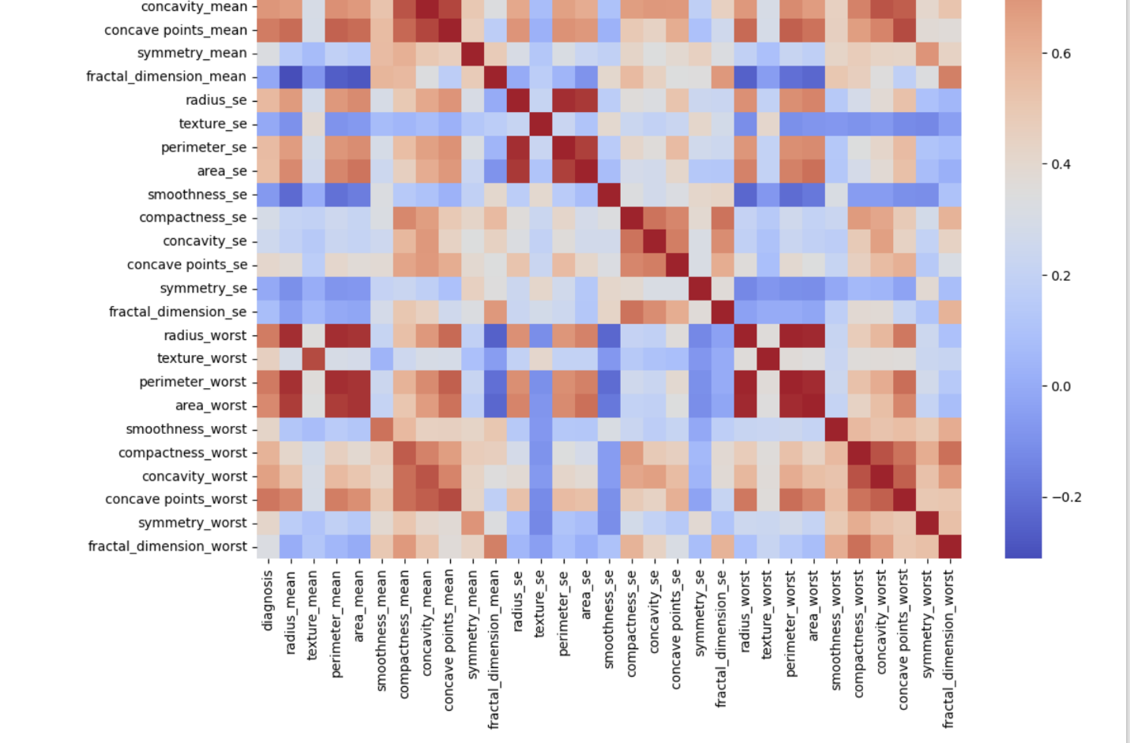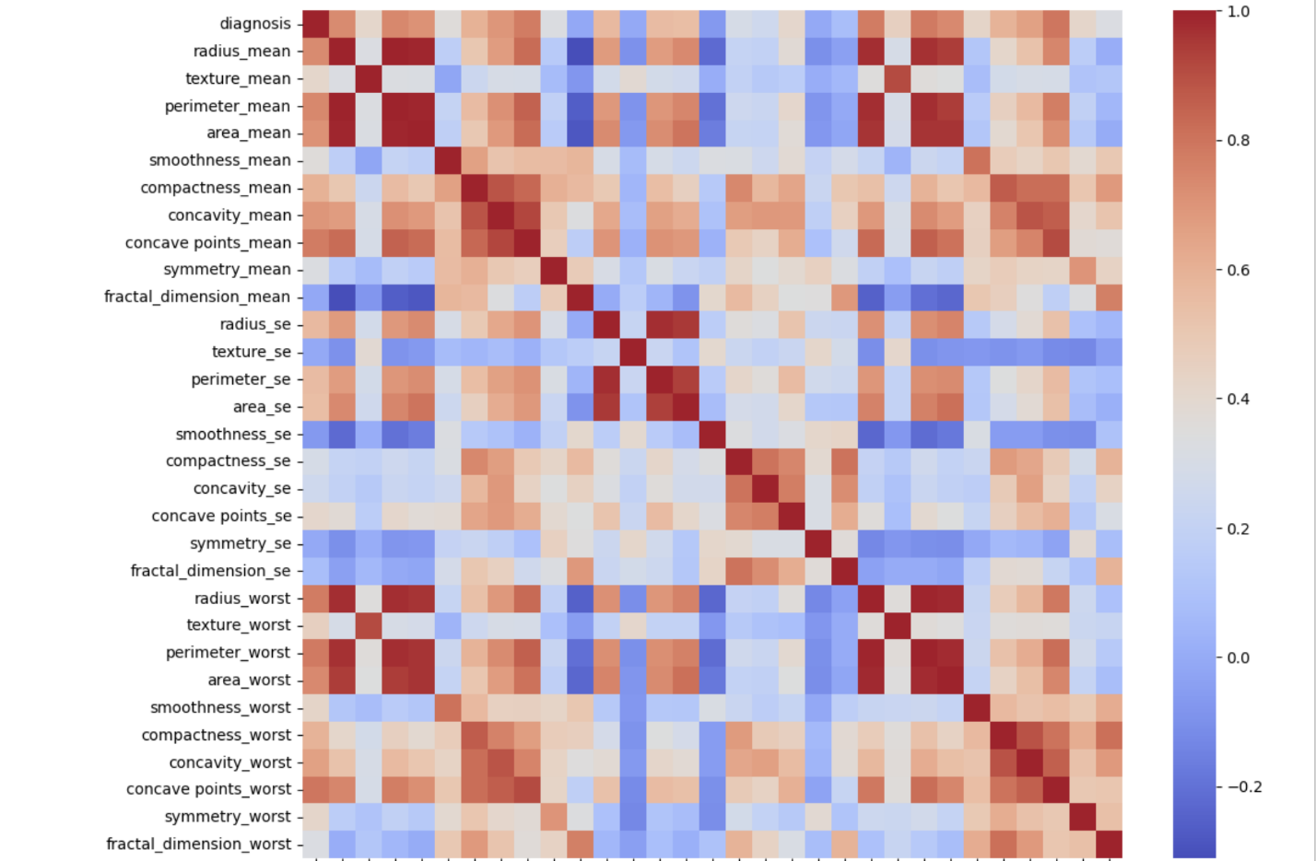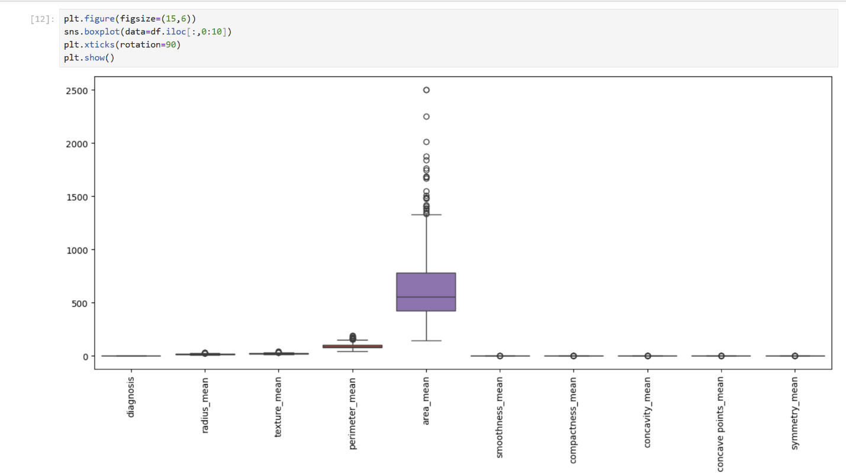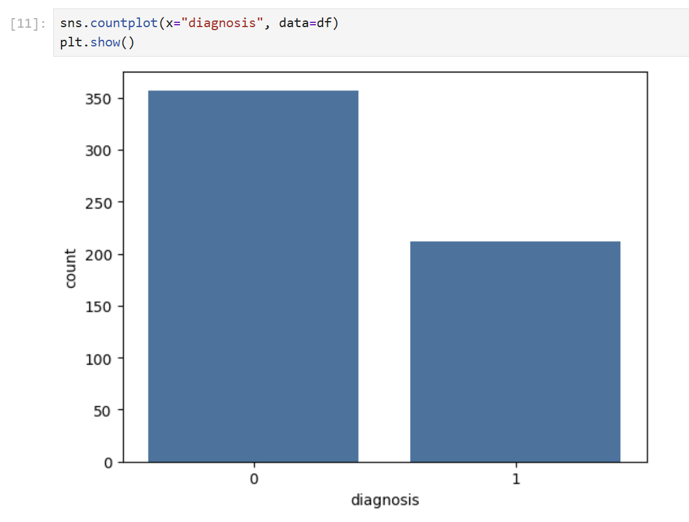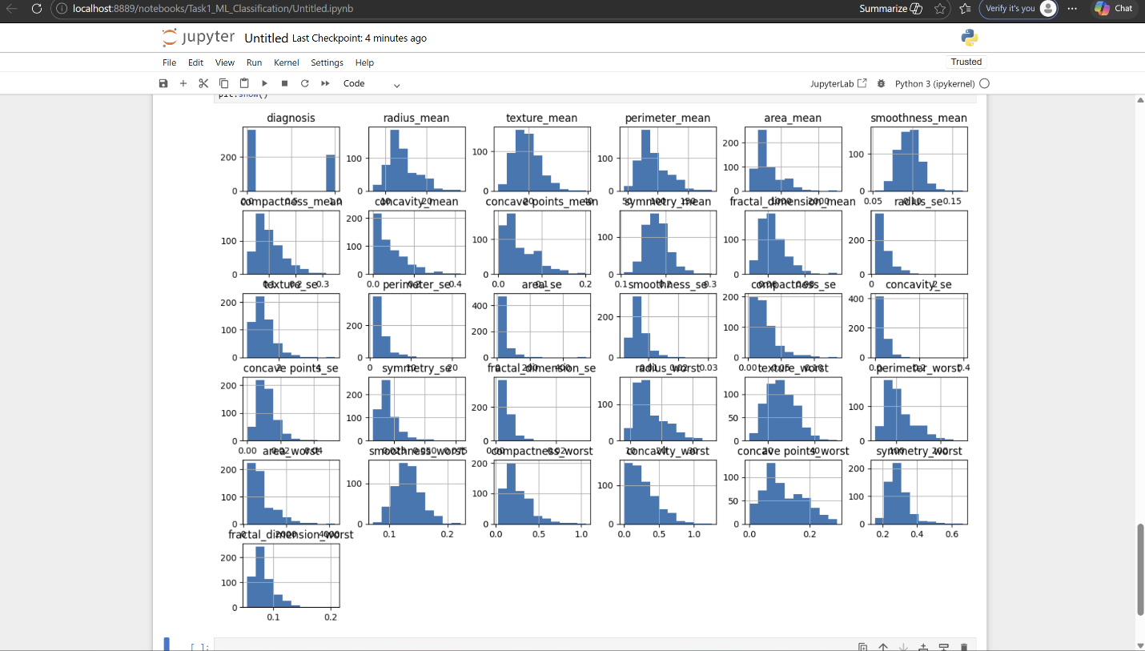.
7. Machine Learning Model
Logistic Regression was used as the classification algorithm for predicting breast cancer diagnosis.
8. Model Training
The dataset was split into training and testing sets using an 80-20 ratio. The model was trained on the training dataset.
9. Evaluation Metrics
The model was evaluated using:
- Accuracy Score
- Confusion Matrix
- Classification Report
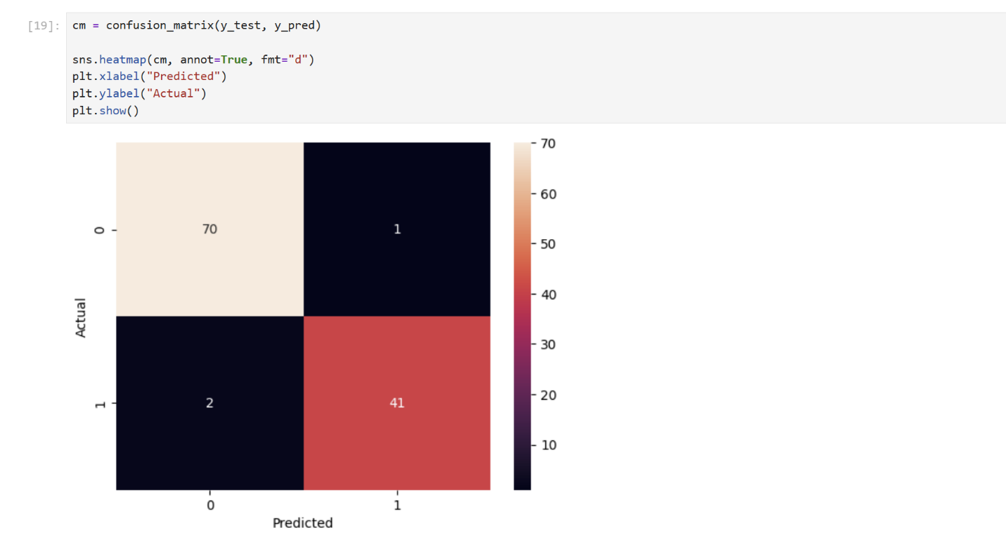
10. Results
The machine learning model achieved high accuracy in predicting breast cancer diagnosis.
Accuracy: 97%
11. Conclusion
The project successfully demonstrated the application of machine learning techniques for breast cancer prediction with high accuracy.
12. Future Improvements
Future improvements may include using deep learning models and deploying the model using Flask or FastAPI.

